**E-Commerce Consumer Behavior Analysis**  
 **Prepared by:** Wael Albakri  
 **Date:** 7/10/2025

### **Executive Summary**

This project delivers a data-driven understanding of how customer platform behavior, specifically time spent on mobile apps versus websites, influences annual spending. While initial assumptions may suggest that greater time spent on the website should yield higher revenue, the analysis tells a different story. This report emphasizes the importance of mathematical rigor and predictive modeling in shaping marketing strategy and resource allocation.

### **Strategic Objective**

To identify which digital touchpoint “mobile” or "web” has a stronger influence on customer spending, and to guide future investment strategies based on empirical evidence rather than surface-level data observations.

### **Key Findings**

Upon conducting an in-depth statistical analysis and regression modeling, it became evident that **mobile app engagement is a significantly stronger driver of revenue** compared to web engagement. Although users appear to spend more total time on the website, that metric alone is misleading without contextual analysis.

One key behavioral insight is that **website visitors often leave browser tabs open while multitasking**, inflating session durations without active engagement. In contrast, mobile app users are generally more focused and intentional in their interactions. This behavioral distinction explains why mobile app usage correlates more positively with purchasing behavior.

Professionals in UX, CRO, and digital marketing, particularly those familiar with **heatmaps and session replay tools,** can relate to this phenomenon. Time spent is not synonymous with attention or intent.

### **Data-Backed Insights**

Through regression modeling, the project uncovered that:

* **Time on App** has a **strong positive relationship** with yearly spending.
* **Time on the Website** exhibits **a very weak and even slightly negative relationship**, suggesting it is not a meaningful predictor of revenue.

This reinforces the principle that **raw numbers are not always indicative of performance**. Only through proper statistical methods and predictive modeling can we uncover the true levers of customer value.

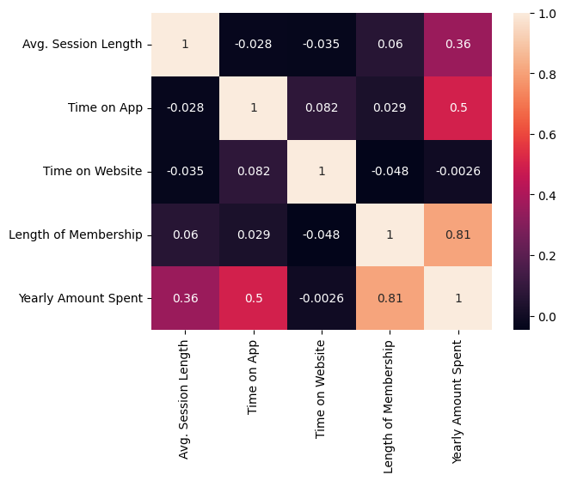

### **Predictive Modeling**

A linear regression model was developed to predict **future customer spending** based on behavioral features. The model allows the business to:

* Forecast profit potential based on user activity.
* Identify high-value customer segments.
* Strategically personalize marketing based on app engagement levels.

This model is built with the intent to be integrated into marketing automation tools or dashboards to inform campaign targeting and retention initiatives.

### **Recommendation**

**I strongly recommend increasing investment in mobile app development and engagement strategies.** This includes enhancing the user experience, expanding loyalty features, and driving mobile-specific promotions.

Simultaneously, it is advisable to reconsider the role of the website in the customer journey. While it remains an important brand touchpoint, its impact on direct revenue appears limited compared to the mobile platform.

### **Final Thought**

This project demonstrates that **data without proper analysis can lead to incorrect business decisions**. Time spent on a channel is not enough; what matters is the **quality of engagement and the intent behind the interaction**. By applying statistical reasoning and predictive modeling, we transform assumptions into actionable strategies.